DATA ANALYTICS INTERNSHIP
PROJECT REPORT
Project 1: Data Cleaning & Preparation
Name: Muskan Sharma
Email: Muskandel2006@gmail.com
Organization: DecodeLabs
Batch: 2026

1. Objective
To clean a raw dataset by identifying missing values, checking duplicate records, and standardizing data formats for accurate analysis.

2. Tools Used
• Microsoft Excel
• DecodeLabs Dataset

3. Methodology
Step 1: Opened the dataset in Excel.
Step 2: Identified missing values in the CouponCode column.
Step 3: Replaced blank values with 'No Coupon'.
Step 4: Checked for duplicate records using Excel tools.
Step 5: Verified uniqueness of Order IDs.
Step 6: Standardized date formats.
Step 7: Saved the cleaned dataset.

4. Results
Total Records: 1200
Missing Values Found: 309
Missing Values Resolved: 309
Duplicate Rows: 0
Duplicate Order IDs: 0
Incorrect Date Formats: 0

5. Screenshots
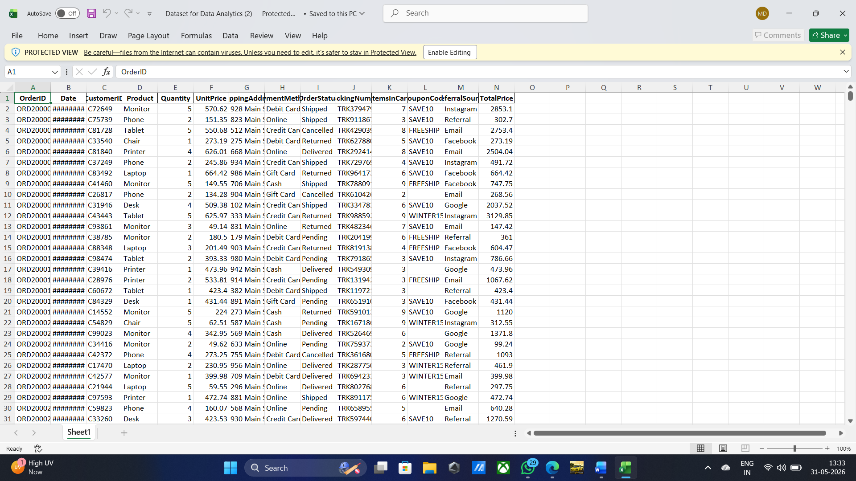

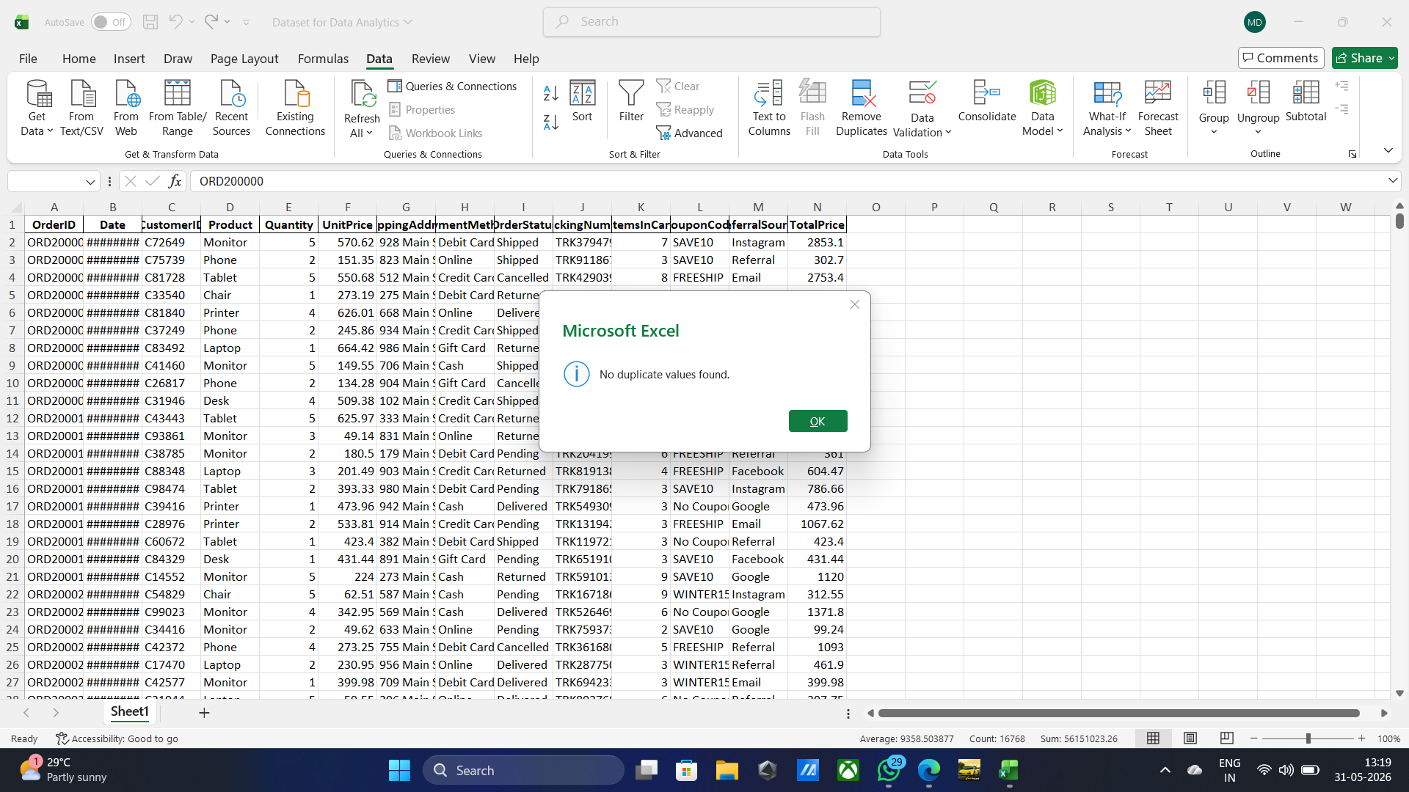
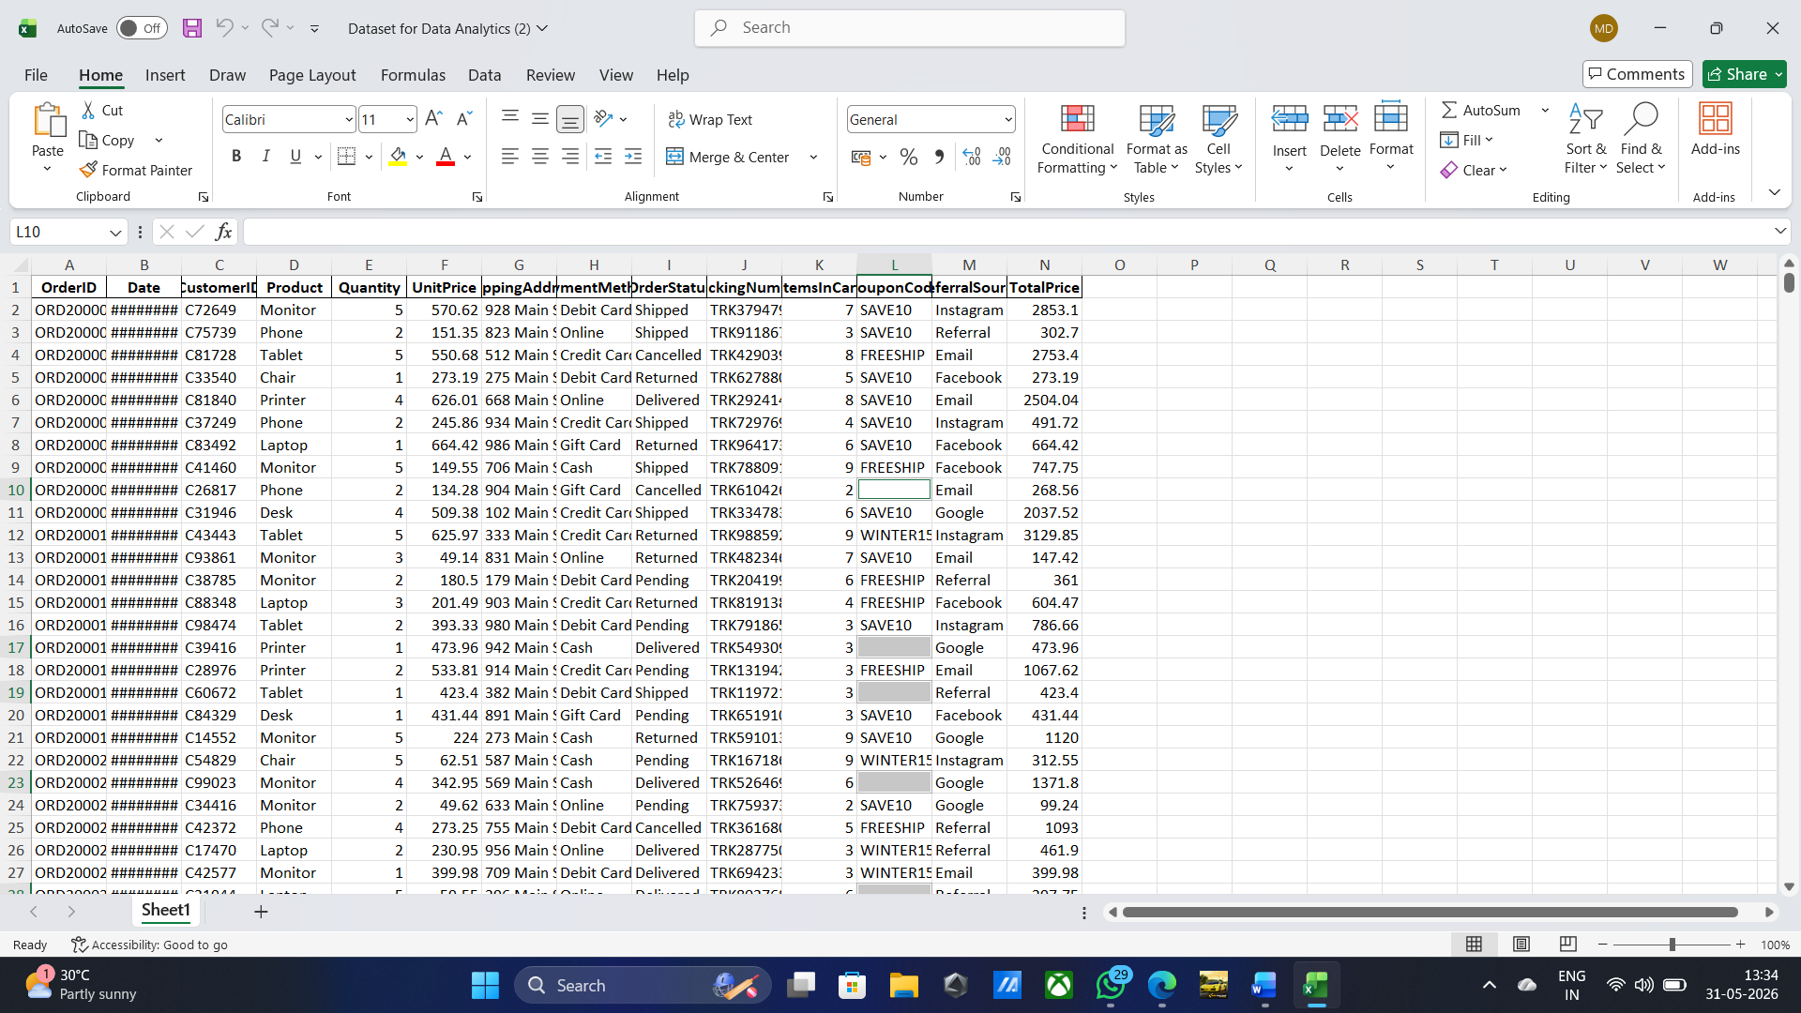
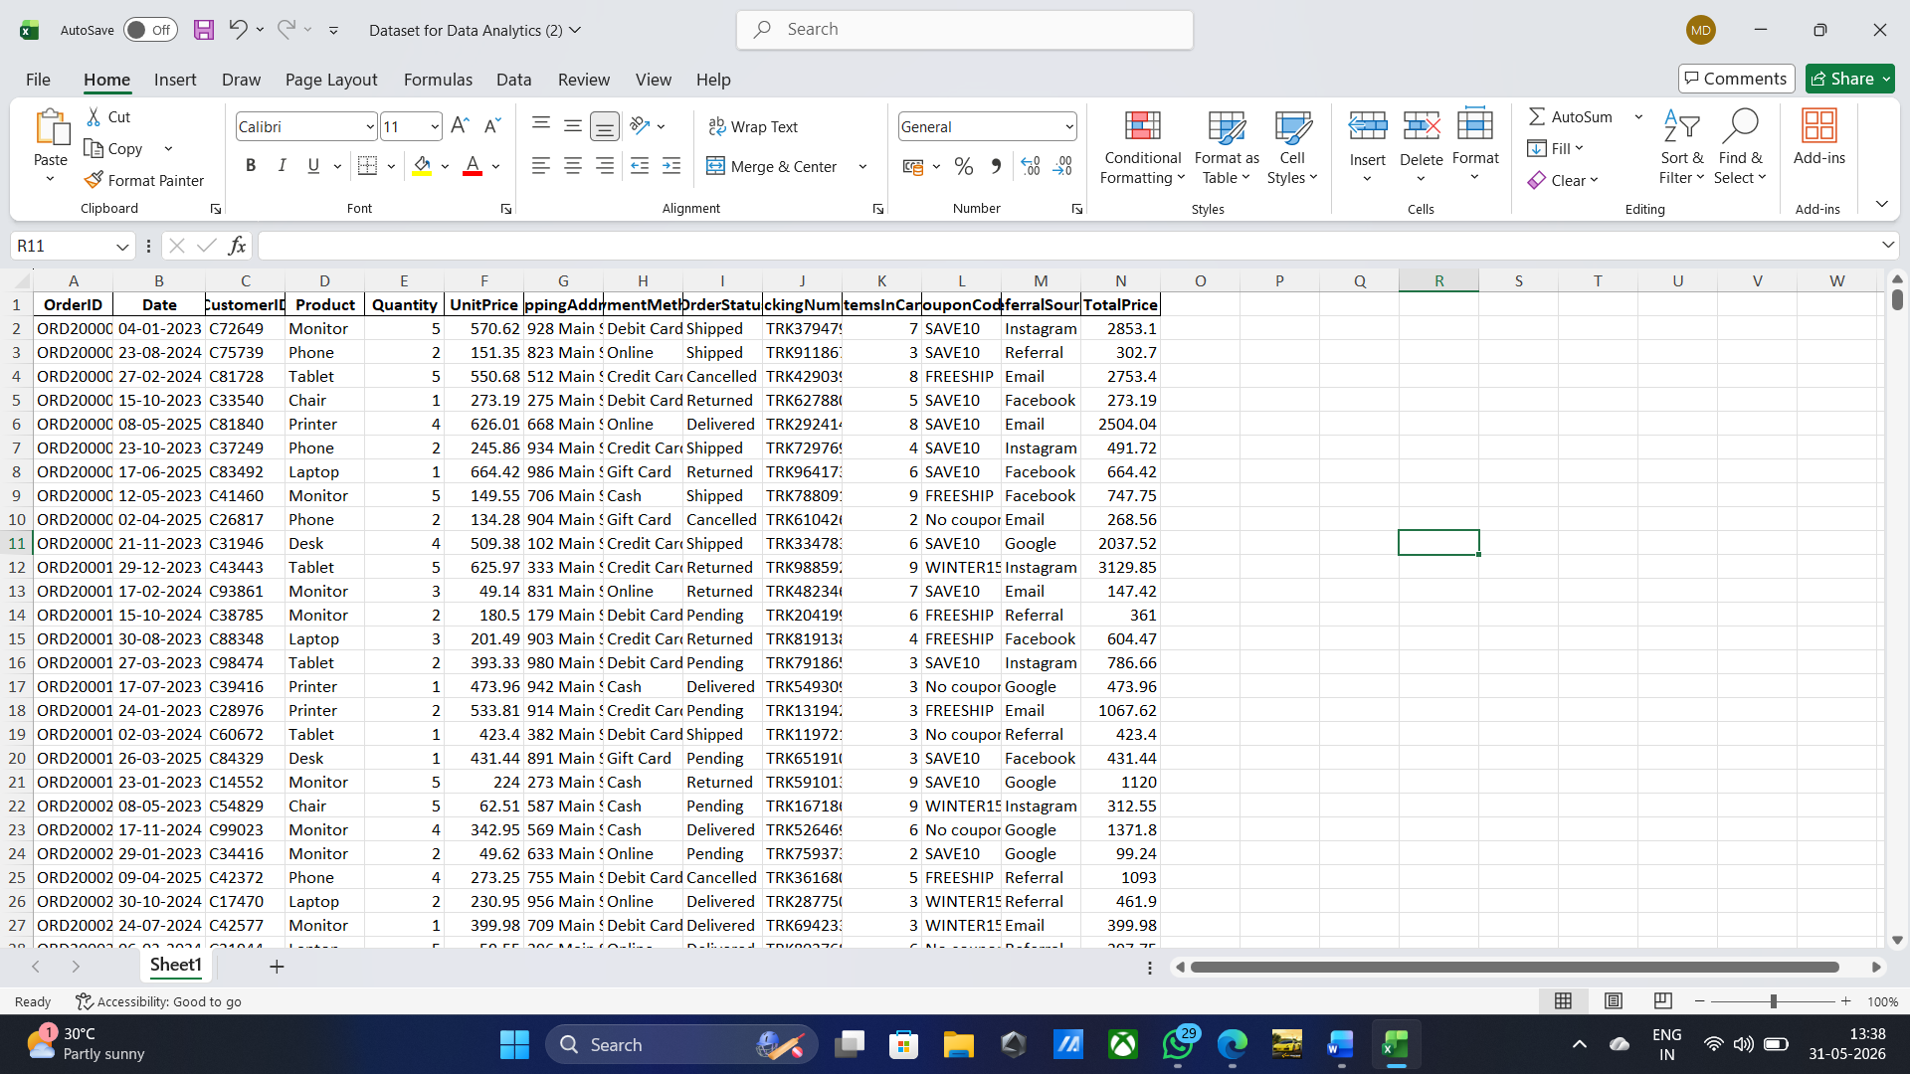

6. Conclusion
The dataset was successfully cleaned and prepared for further analysis. Missing values were handled, duplicate records were checked, and data formatting was verified.

